**Introduction to Databases**

**Date 04/feb/2021**

Problem Statement: There can be multiple customers, who can place multiple orders on the site. Now a sales person can handle these orders will distribute into multiple sales persons (One order will be assign to one salesperson only). So a sales person can have multiple orders of multiple customers

1. Create Database

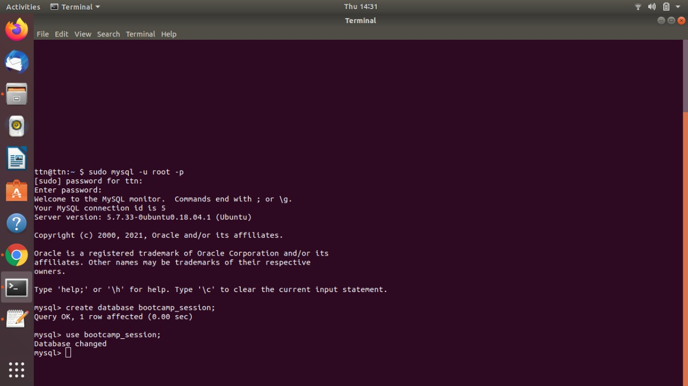

1. Design Schema

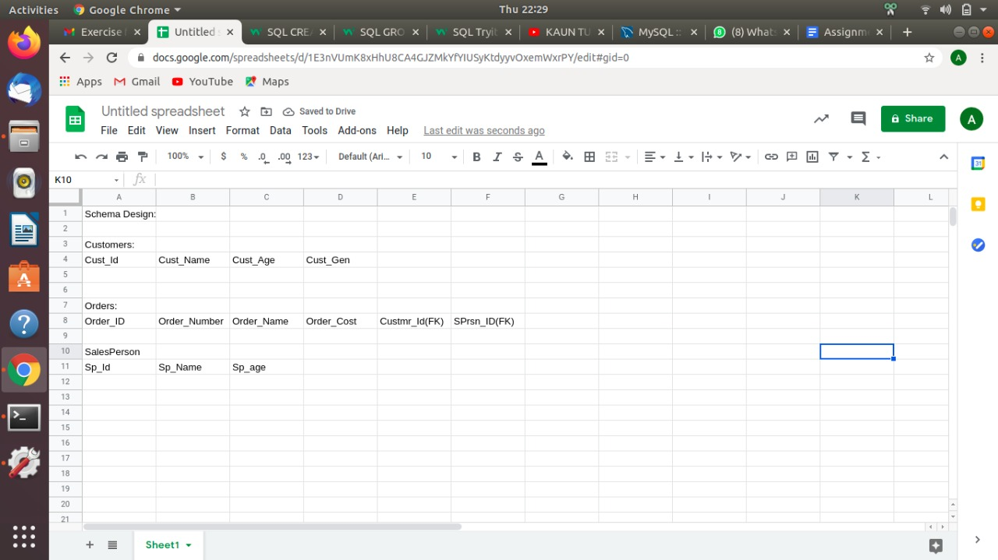

1. Create tables

Customers table:

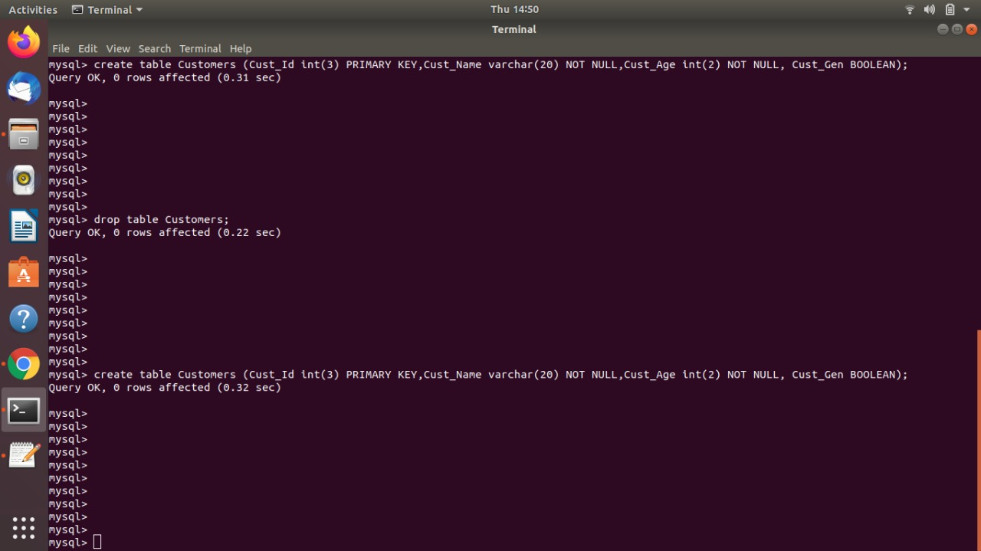

SalesPerson table:

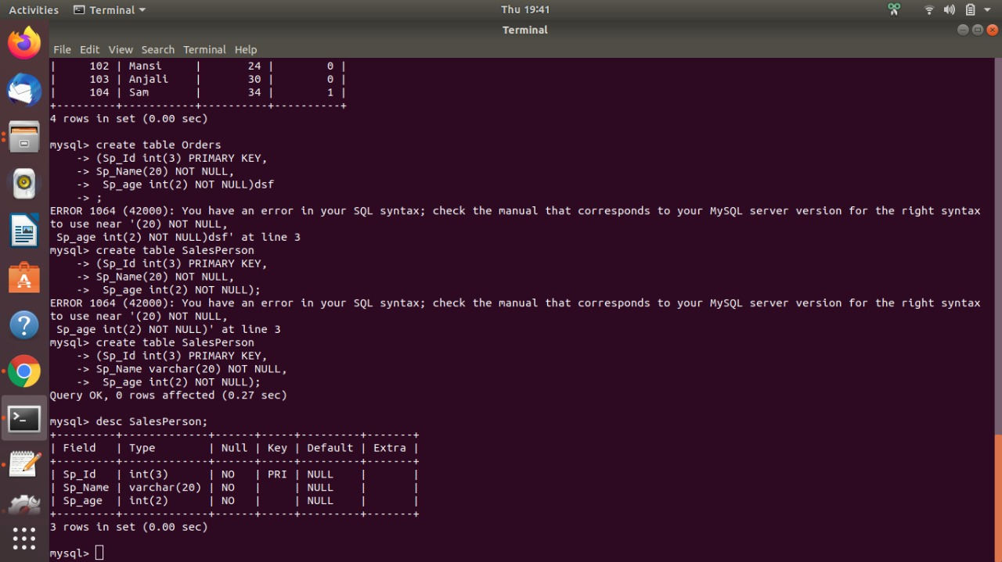

Orders table:

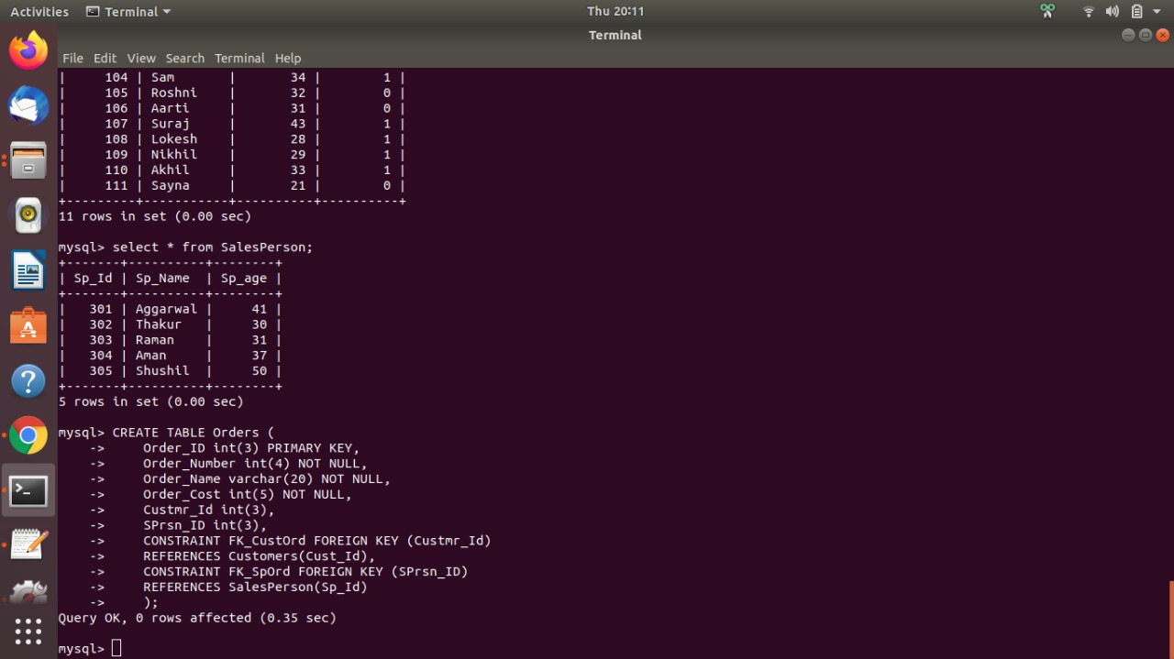

1. Insert sample data

Customers Table: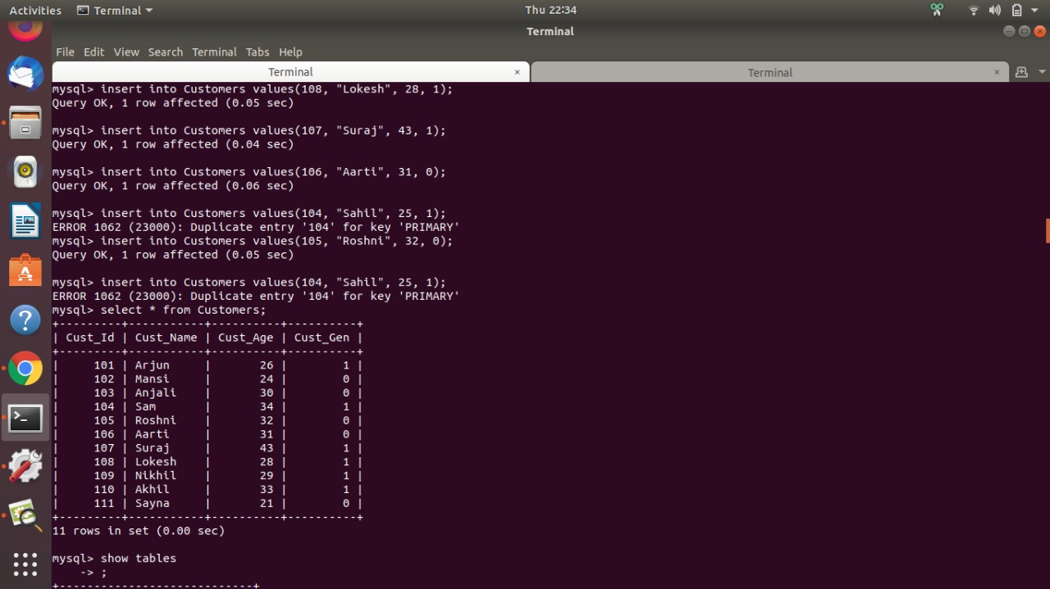

SalesPerson table:

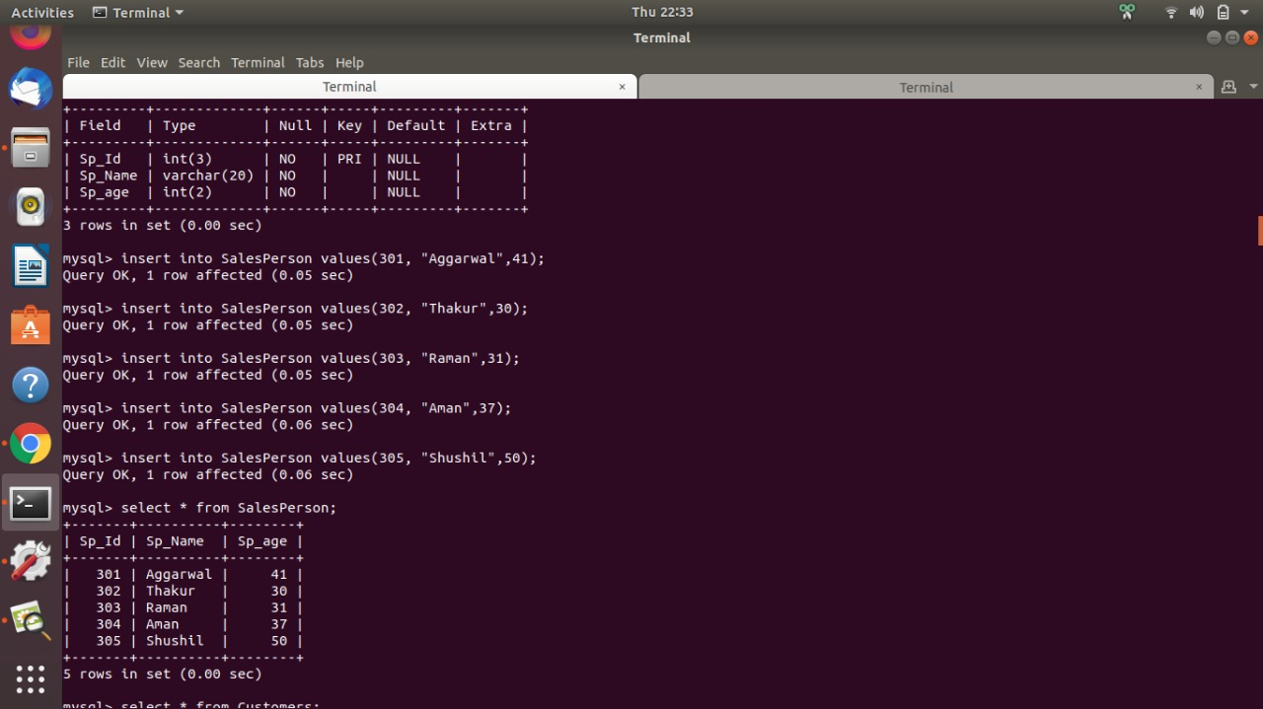

Orders table:

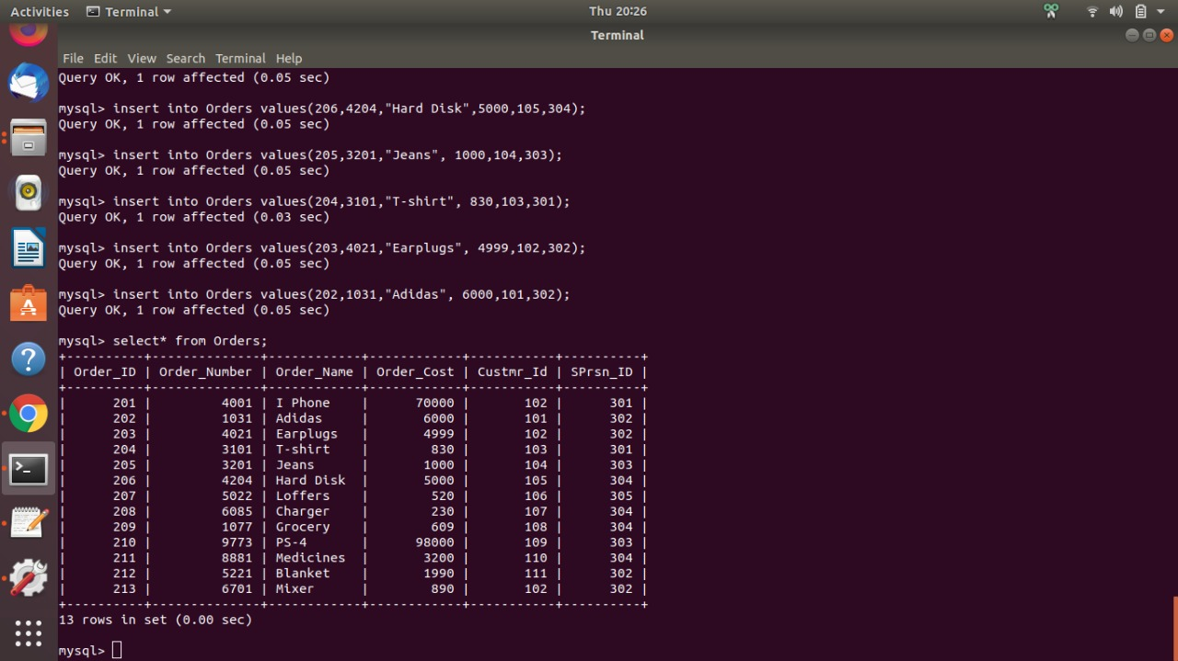

1. Find the sales person have multiple orders.

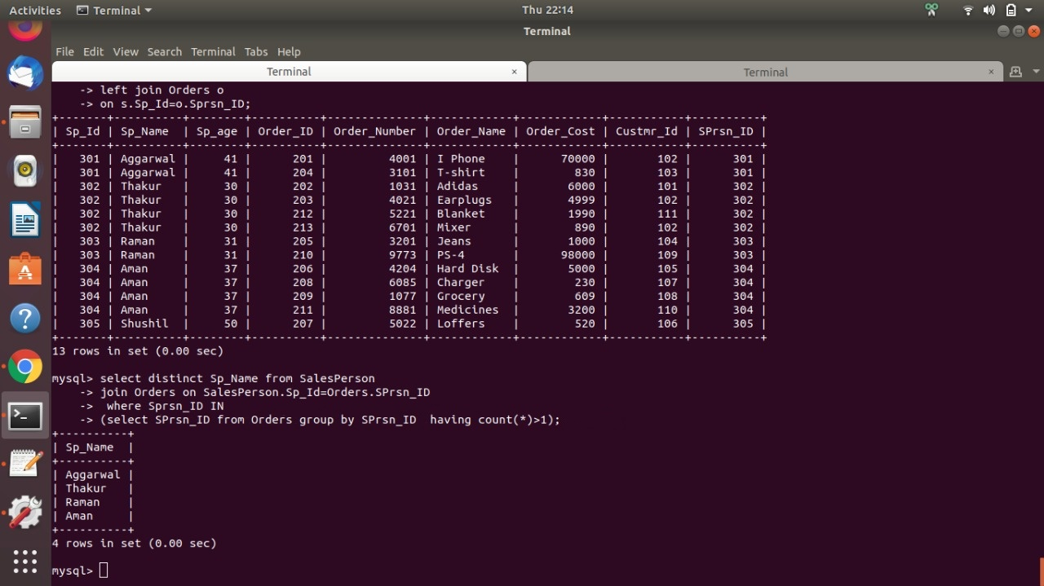

1. Find the all sales person details along with order details.

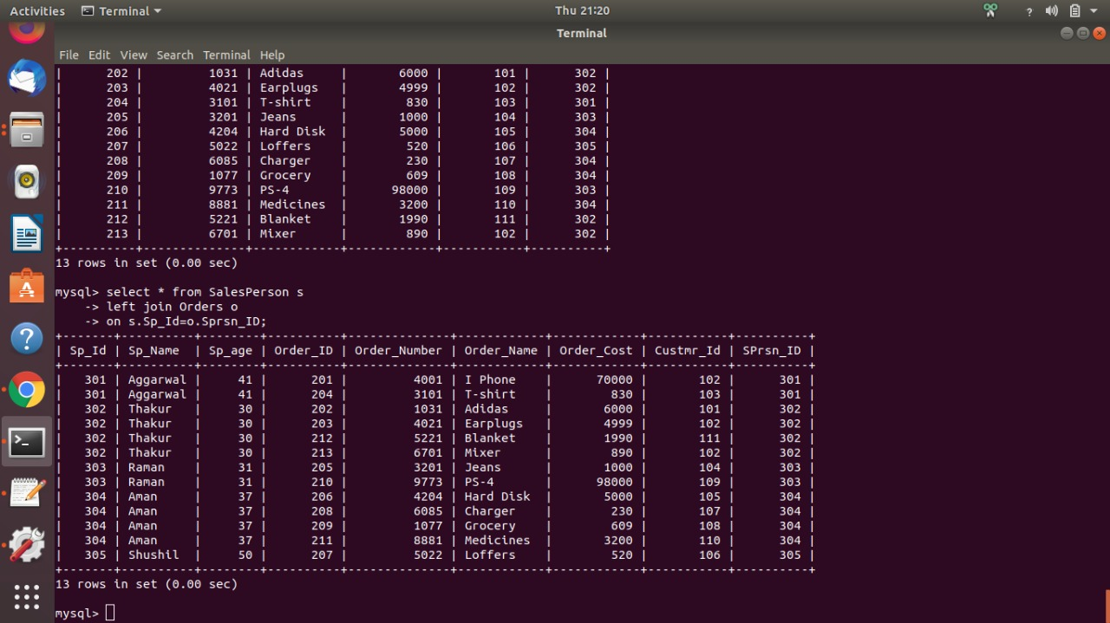

1. Create index.

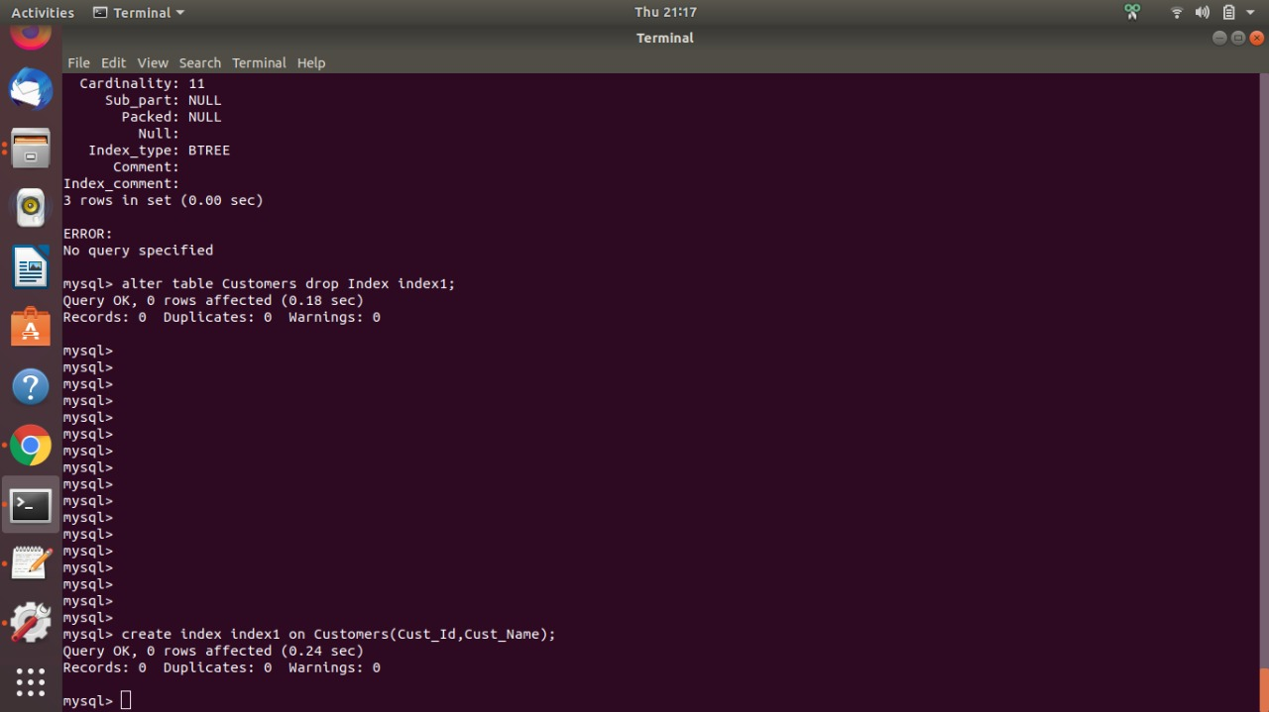

1. How to show index on a table.

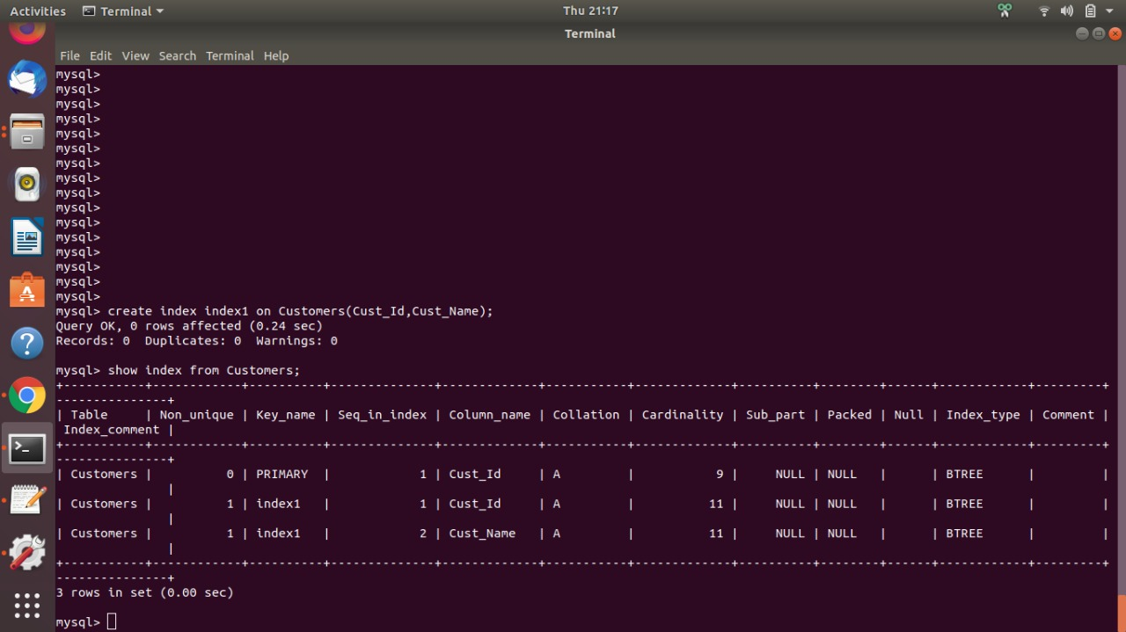

1. Find the order number, sale person name, along with the customer to whom that order belongs to.

